**Project Title**

SLA Management for Hardware Group - Priority 4

**Project Description:**

To implement and manage an SLA in ServiceNow for hardware-related incidents categorized as Priority 4, ensuring incidents are addressed within 16 business hours, pausing the SLA when the incident is on hold, and stopping the SLA when the incident is resolved or closed.

**Implementation:**

**………………………………………………………………………………………….**

**Activity-1**

1. Open service now developer Instance
2. Click on All
3. Search for SLA Definition  
   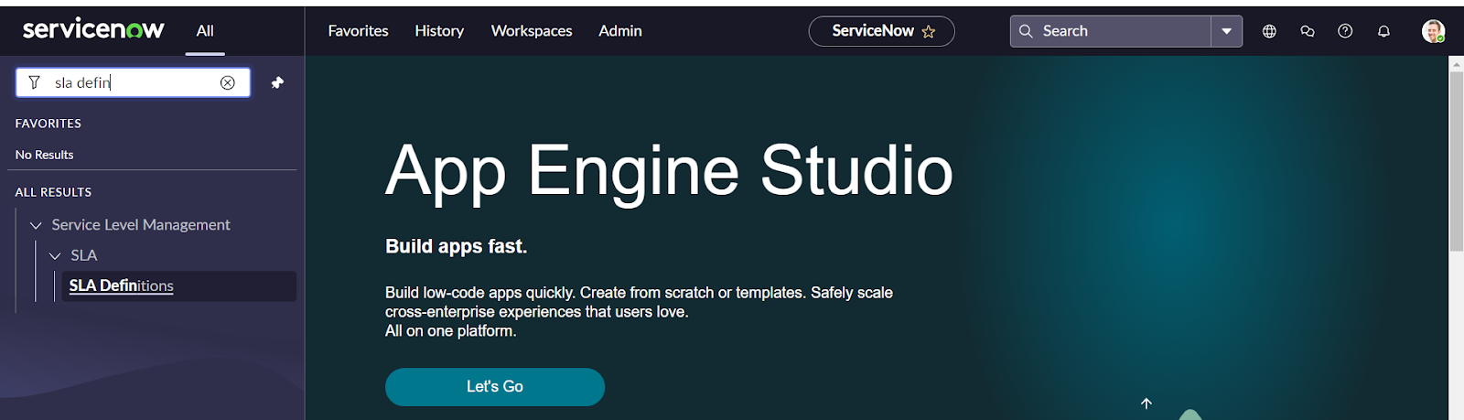
4. Create New
5. Fill the information as mentioned below  
   Name : Hardware Group - Priority 4  
   Type : SLA  
   Target : Response  
   Table : incident  
   Duration : 1 hour

Schedule source : No schedule  
Leave the other things default

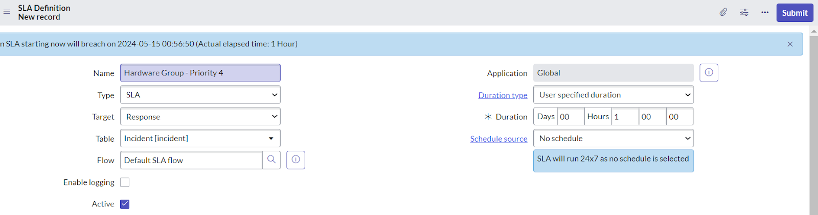

1. Under start condition fill the given information  
   Active>>is>>true  
   Priority>>is>>4-low

State>>is>>New

1. Under when to cancel choose

When start condition is not met.

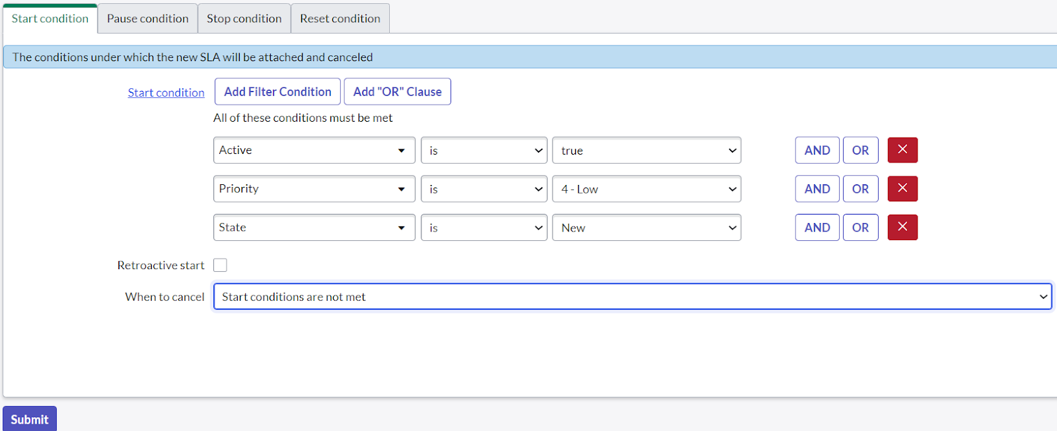

1. Under stop condition  
   Assignment group >> is not empty

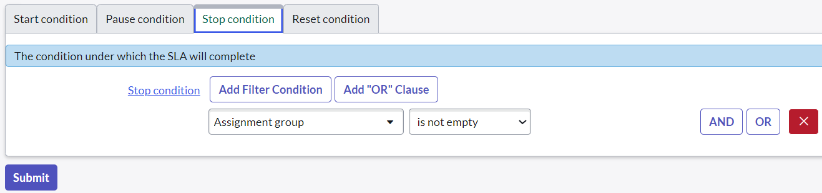

1. Click on submit.

**Activity - 2:**

1. Click on All
2. Search for SLA Definition  
   
3. Create New
4. Fill the information as mentioned below

Name : Hardware Group-Resolution  
Type : SLA  
Target : Resolution  
Table : incident  
Duration : 16 hour

Schedule source : No schedule  
Leave the other things default

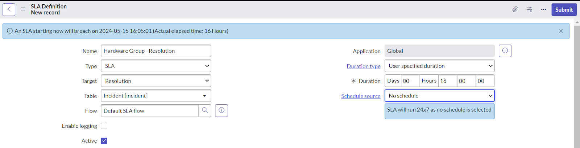

1. Under start condition fill the given information

Assignment group >> is not empty

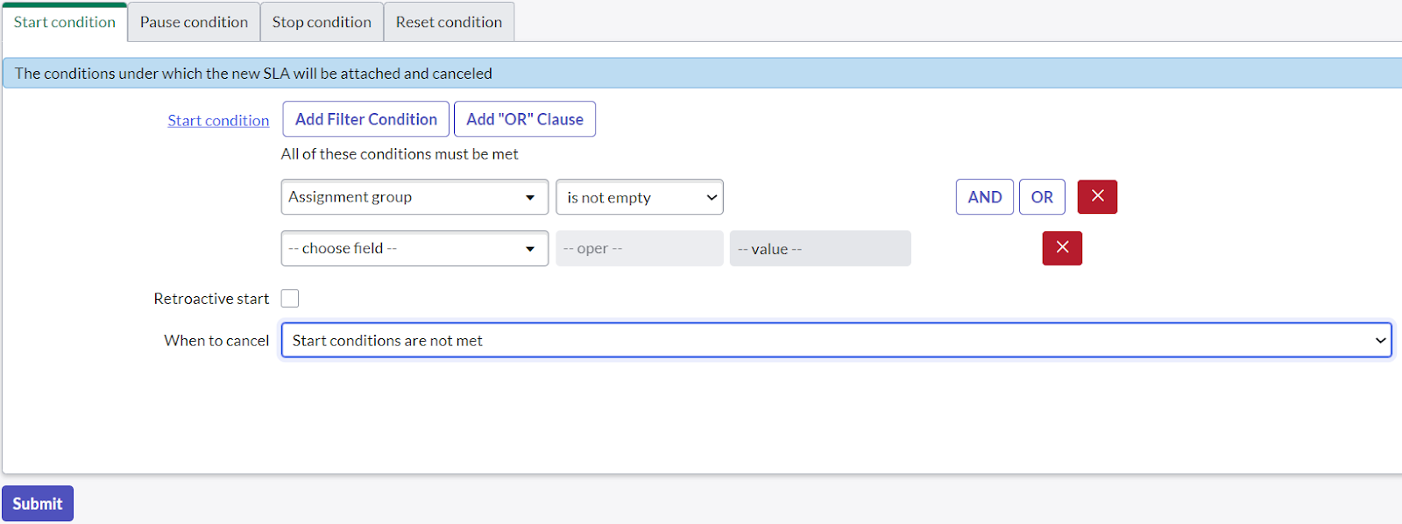

1. Under pause condition fill the following information  
   state>>is>>onhold
2. Under when to resume choose  
   When pause conditions are not met

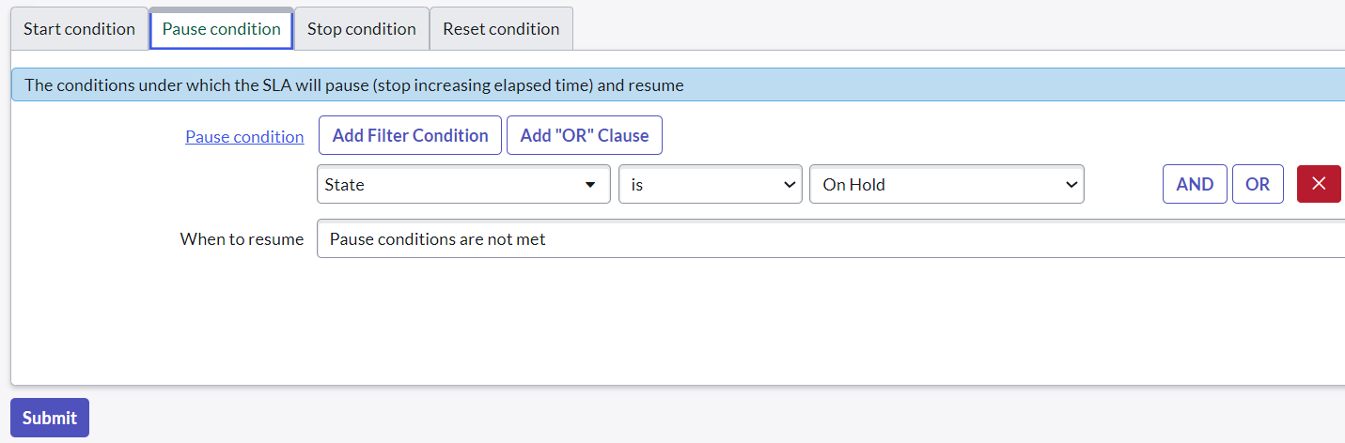

1. Under stop condition fill the following information  
   State>>is one of>>resolved,closed  
   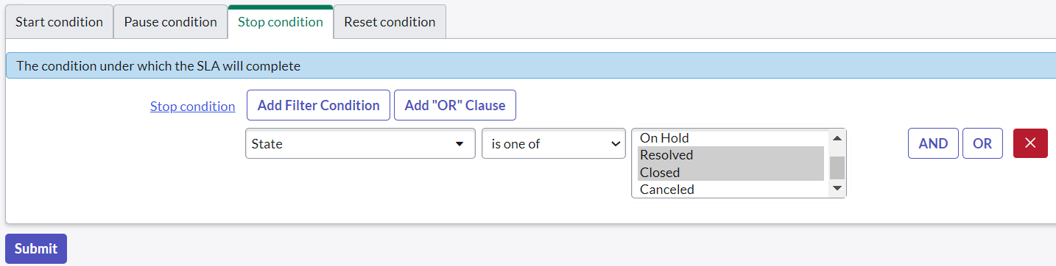
2. Click on submit.

**MyResults:**

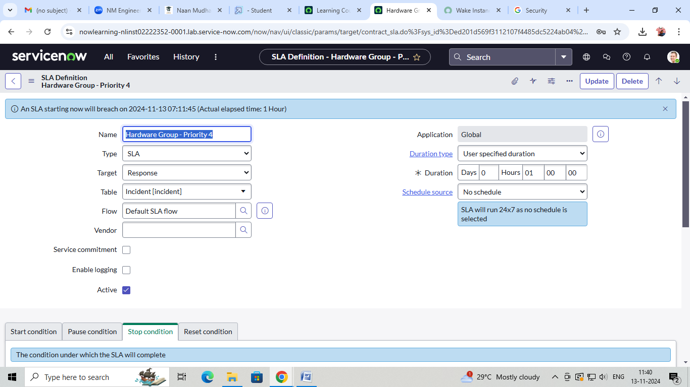

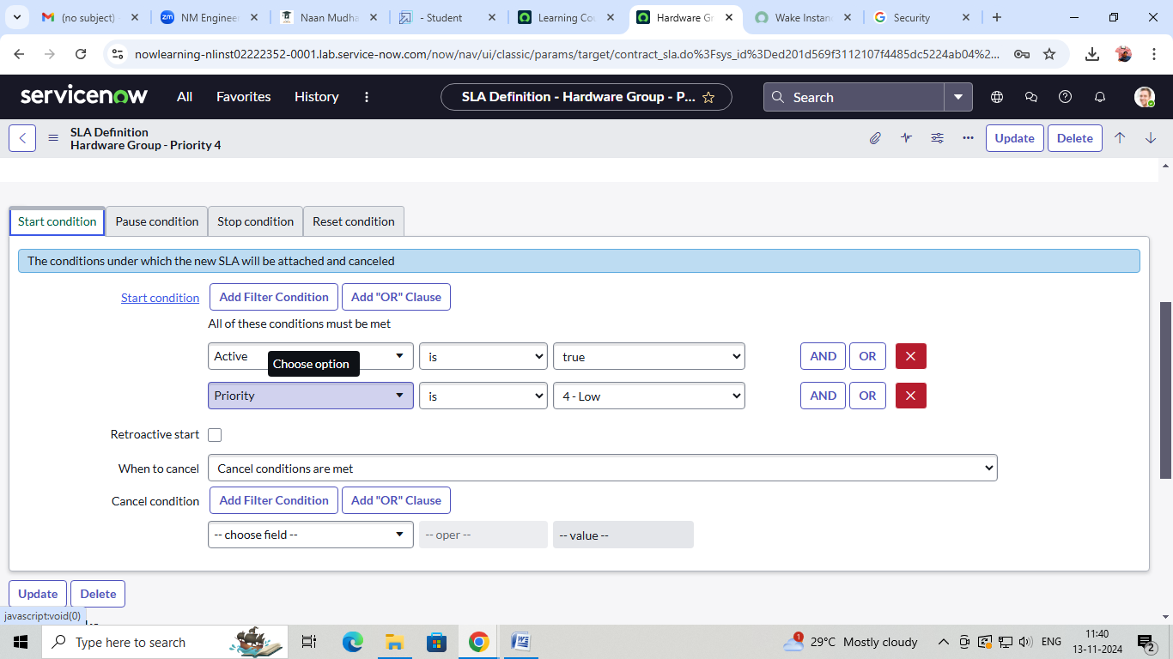

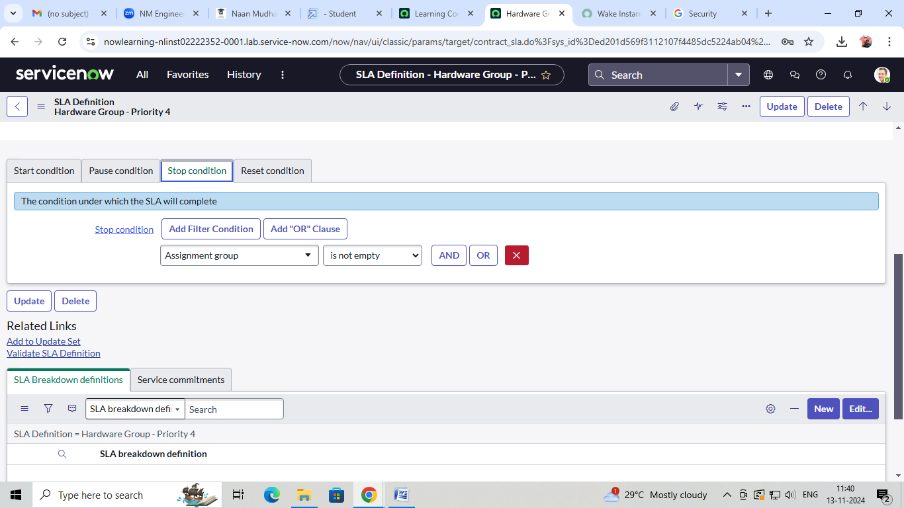

**Project – 2:**

